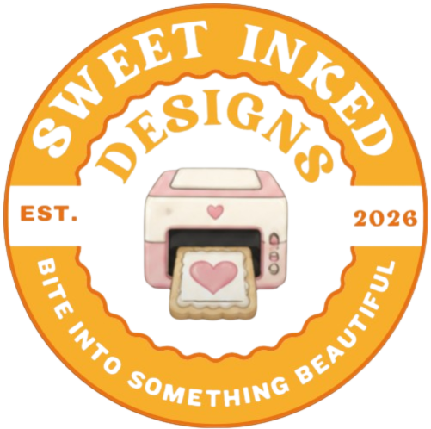

Sweet Inked Designs

Custom Treats & Personalized Gifts Price Sheet
 Sweetinkedesigns@gmail.com 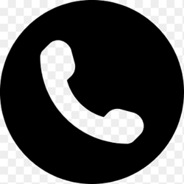 405.326.9087
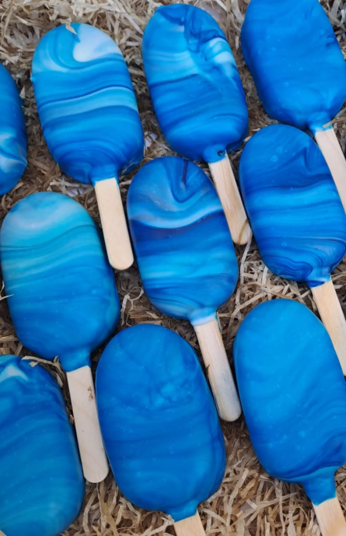

Cakesickles 3” size
Quantity | Standard | Personalized
Each | $4.00 | $4.50
1 Dozen | $40 | $50
2 Dozen (2 Flavors) | $90 | $100
4 Dozen (2 Flavors) | $150 | $185
*flavor options below

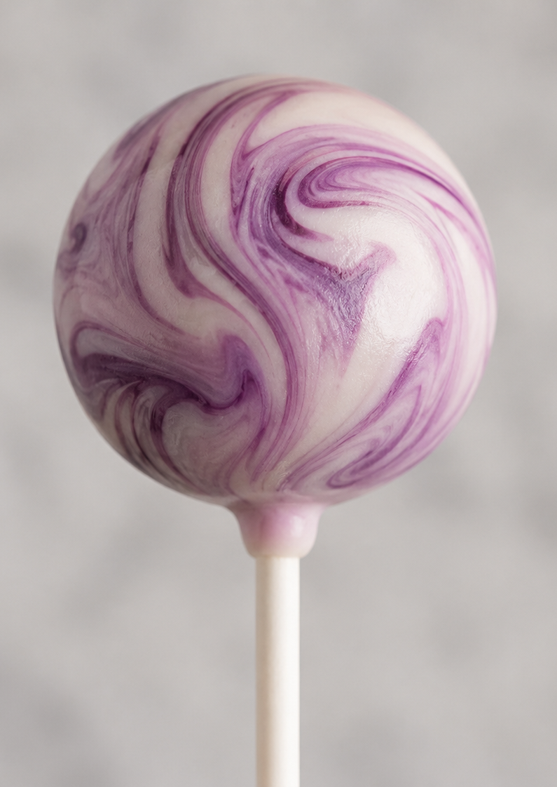
Cake Pops 1.5”–2.0” size
Quantity | Standard | Personalized
Each | $3.00 | $3.50
1 Dozen | $30 | $36
2 Dozen (2 Flavors) | $75 | $90
4 Dozen (2 Flavors) | $135 | $150
several shapes available

Cake Balls
Quantity | Price
Each | $2.50
2 Dozen | $40

Personalized Sugar Cookies
Includes up to 2 designs per dozen, each additional design add $5.00
Round or Square Sugar Cookies with your choice of royal icing or Rolled Buttercream
Size | Price per Dozen
2.5” | $30
3.0” | $35
3.5” | $40
4.0” | $45

Additional Options
- Custom shape cookies available
Almond Bark/Chocolate Covered Oreos
Various Oreo flavors available
Quantity | Standard | Personalized
1 Dozen (Marbled – 2 Colors) | $25 | $30
4 Dozen (Marbled – 2 Colors) | $85 | $100

Custom Coffee Pods
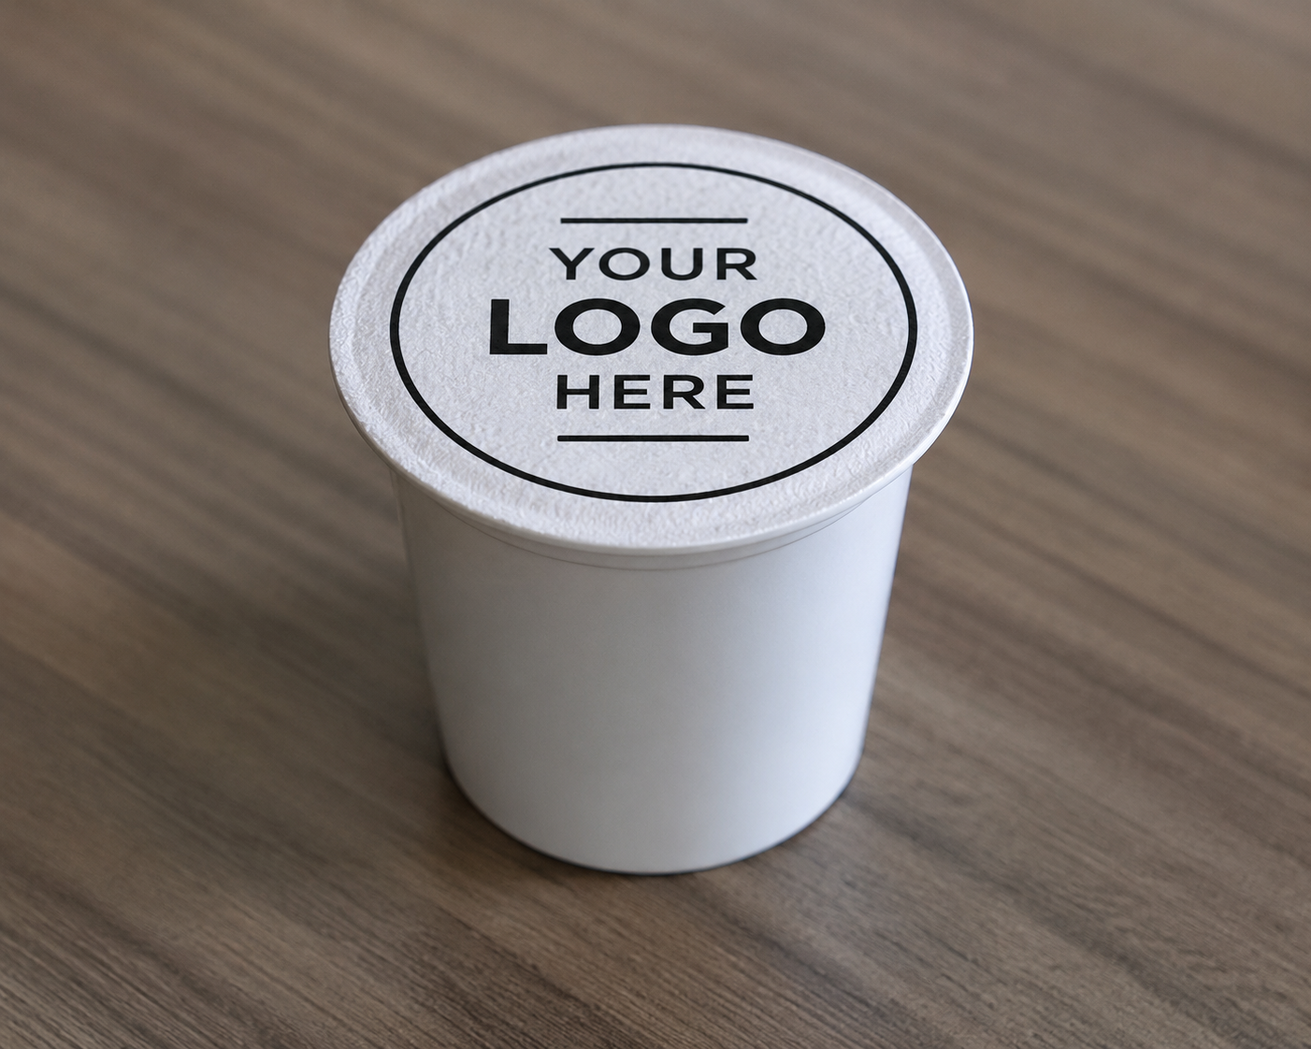
Quantity | Price
Each | $2.00
1 Dozen (1 Design) | $18
Caffeinated or decaf coffee available
Custom Printed Items
- Custom printed edible sheets for cookies or cake starting at $10 per sheet
- Custom designs printed on soaps
- Custom M&Ms
Cake Flavors Available

Outstanding Originals

- French Vanilla
- Mexican Vanilla
- Red Velvet
- Triple Chocolate Fudge
- Buttery Yellow
- Funfetti
- Strawberry

Fruit Flavored (add $5 per doz)
- Orange Creamsicle
- Cherry Chip
- Strawberry Cheesecake
- Lemon Blueberry
- Strawberry Shortcake
- Pumpkin Spice
- Pumpkin Cheesecake
Cereal Based (add $5 per doz)
- Fruity Pebbles
- Captain Crunch
- Cinnamon Toast Crunch

Cookie Based (add $5 per doz)
- Circus Animal Cracker
- Cookies n Cream
- Nutter Butter
- Biscoff
- Tagalong Cookie
- Thin Mint

Snack Cake Pops (add $5 per doz)
- Zebra Cake
- Swiss Roll
- Cosmic Brownie

Mix-In Flavors (add $5 per doz)
- S’mores
- S’mores Bourbon
- Cookie Dough
- Funfetti Cheesecake
- Red Velvet Cheesecake
- Rocky Road
- Better Made
- Honey Jiffy Mix

Candy Based (add $5 per doz)
- Nerds
- Almond Joy
- Butterfinger
- Reese’s Bourbon
- Reese’s Pieces

Holiday Flavors (add $5 per doz)
- Vanilla Candy Cane
- Christmas Tree Cake
- Dark Chocolate Peppermint
- Count Chocula
- Boo Bites
- Pumpkin Pie
- Chocolate Covered Strawberry
- Gluten & Dairy Free Cake Pops Available
We Also Offer Customized Ink on:
- T-Shirts
- Hats
- Candy Boxes
- Tote Bags
- Mugs Pricing subject to change based on design complexity and specialty requests.

